**Anastasia Psarou - Assignment 6 – Machine Learning**

This is my dataflow:

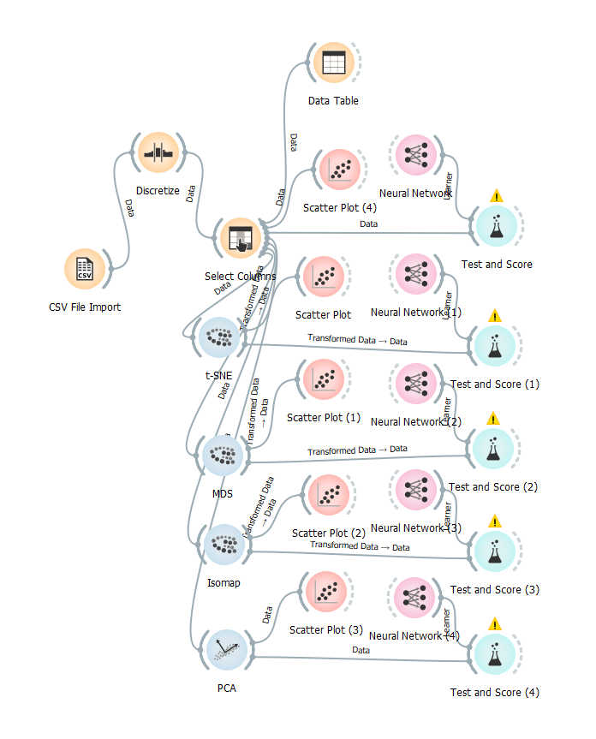

So, we are going to compare the values of Classification Accuracy in the different Test and Score widgets in order to find if these methods can help in obtaining better classification results by using NN.

Firstly, we are going to compare the CA values having a NN with 100 neurons in hidden layers.

Feature Selection:



t-SNE



MDS



Isomap



PCA



From these results we can observe that t-SNE is the method that generates the best CA for 100 neurons in hidden layers. Also, method t-SNE is the only one that produces results better compared to do not having feature engineering algorithms.

Now we are gone use 50 neurons in hidden layers and see if we have any change in the results.

Feature Selection:



t-SNE



MDS



Isomap



PCA



From these results we can observe that t-SNE is the method that generates the best CA for 50 neurons in hidden layers. Also, methods t-SNE and Isomap are the ones that produce results better compared to do not having feature engineering algorithms.

Now we are gone use 200 neurons in hidden layers and see if we have any change in the results.

Feature Selection:



t-SNE



MDS



Isomap



PCA



From these results we can observe that t-SNE is the method that generates the best CA for 200 neurons in hidden layers. Also, only method t-SNE is the one that produces results better compared to do not having feature engineering algorithms.

Lastly, we are going to take a look at the scatter plots.

Feature Selection:

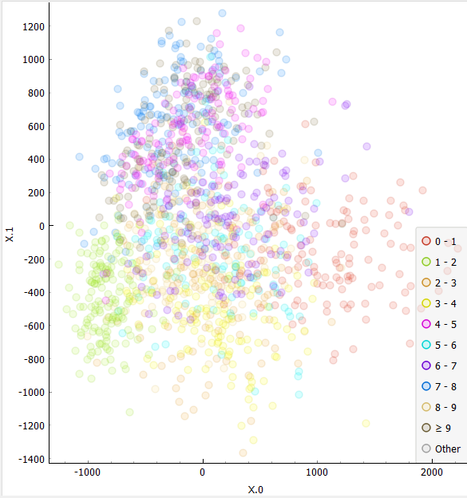

t-SNE

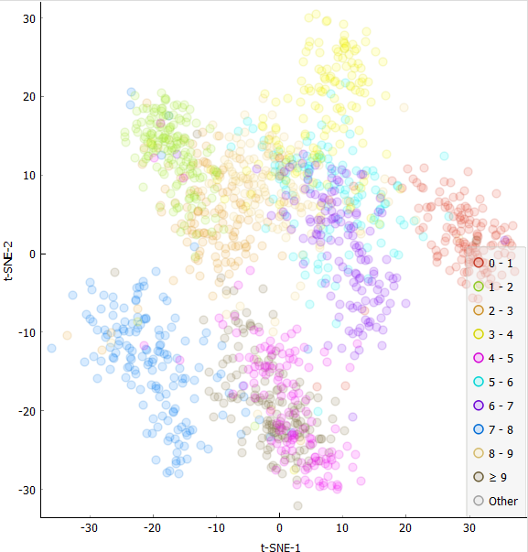

MDS

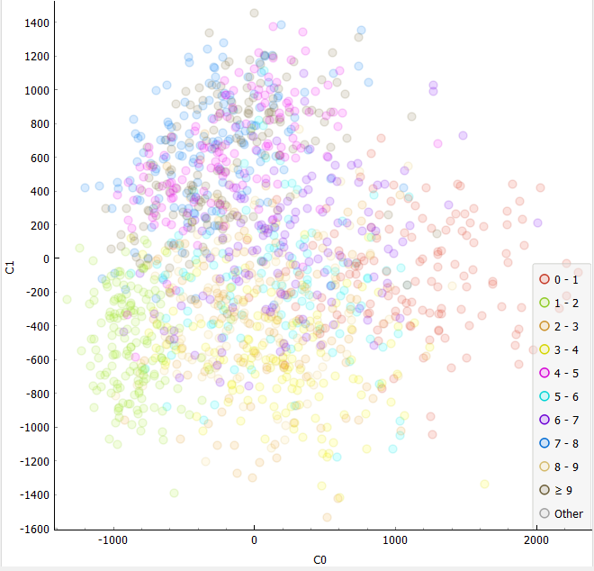

Isomap

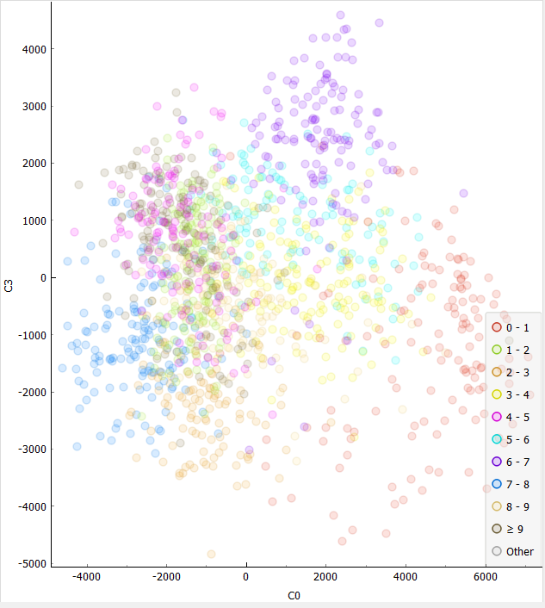

PCA

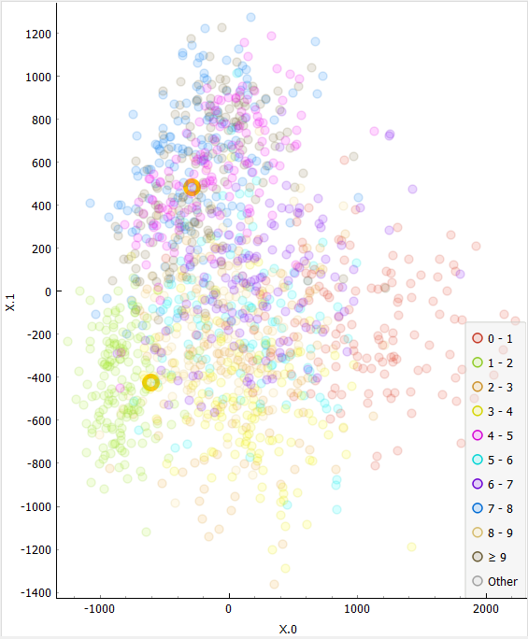

From these Scatter Plots we can see that t-SNE is the feature engineering algorithm that has the more discrete values, compared to PCA, Isomap, MDS.

Finally, we should point out that PCA algorithm seems a good algorithm as far as classification is concerned as in the above experiments it generates the same CA value as not using a feature engineering algorithm. Although, t-SNE produces even better results so it is the only algorithm from above that can help in obtaining better classification results by using NN.